This final project has many java files to showcase the different concepts of each chapter. Here is a classification that will help you understand the whole folder.

1. Group 1
   1. Food.java
   2. Order.java
   3. Main.java
2. Group 2
   1. Donations.java
   2. ItemsDonation.java
   3. ItemsDonationsTest.java

Group 1 is about a menu ordering system (that demonstrate the concepts of chapter 1-8, 10 and 11), and group 2 is about a donation program (that showcase chapter 9, 13, and 14).

Group1

This is the menu ordering system. It provides the user with a menu of 3 sandwich that he/she can select from by entering the name of the sandwich. The user can order 3 times and each order is identified 1, 2 or 3. If the sandwich name entered by the user is in the menu, then the program ask for the size of the sandwich desired. The name and the size are taken from Main.java and are processed in Order.java that has methods that handle the recognition of the sandwich name, the price settings, the order price calculation. It has parallel array between the name of the sandwiches and their price so the requested sandwich is linked to its price and returned to the user.

Food.java is to set the menu that is a list of sandwich objects with name, condiments, bread style and price as parameters.

Another interesting thing about the menu ordering system is a short article title that talks about the restaurand and tells the order price of the user.

N.B: If the user is running the program more than one time, before each execution, it is recommended to delete the previous file (newspaper.txt) for an update of the new data entered in the program. Also modify the path of creation of the file for the convenience of the user is required since the developer and the user don’t have the same folders.

Group 2

This is the donation program. It presents to the user a list of needed items that he/she can choose from to donate. The user can donate multiple items and stop whenever he/she wants (while loop). When stopped, the program take the items entered by the user and insert them in a list that is later printed in a separate window. The main purpose of this group is to demonstrate inheritance.

Developer’s Note (D.N): Earlier in the development of the final project, the initial idea was to submit group 1 only. But as we were learning new chapters, the group was saturated and needed me to create another concept to demonstrate the recent chapters.

Program demonstration with screenshots

Here is a demonstration of the programs with their screenshots.

Group 1

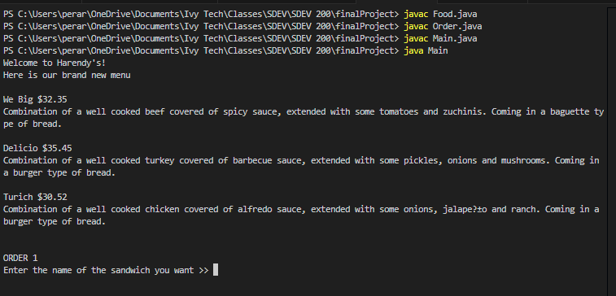

*start of the program.*

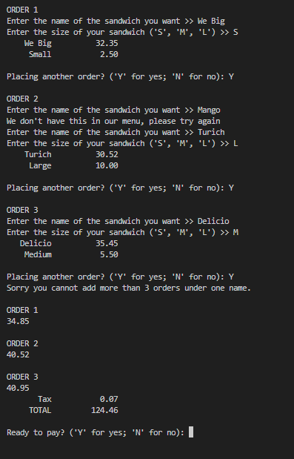For this execution, I ordered a small “We Big”, large “Turich” and a medium “Delicio”. I made sure to show how the program will respond when the name of the sandwich is not in the displayed menu and a temptative to order more than 3 sandwich (which is not allowed). Then the program displays the total for each entry, and the total after all entries calculated with the tax. At this point we are about to pay.

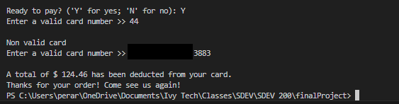In previous benchmark I talked about the Luhn’s algorithm that helps validate any credit/debit card. I used it over here and therefore if the card number you entered is not valid, the program will ask you to enter a valid one until you do. Once the card is verified and valid, the program print a message telling you how much was deducted from the card and create the newspaper.txt file that talks about the restaurant and the price of the order made.

*Example of the newspaper.txt* (This is the result of previous tests and this is the reason why it is not showing $ 124.46 instead of $45.31. That’s why it is recommended to delete the previous file if you plan to run the program again, so the file has updated data.

Group 2

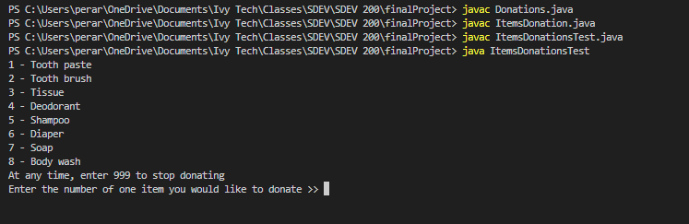*Start of the program*

For this example, I will donate a shampoo, a soap, and a Tooth brush.

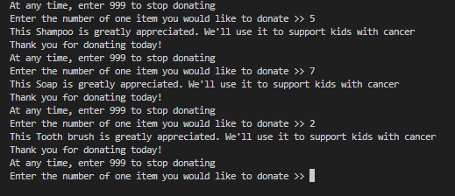After donating each items mentioned, the program connect with ItemsDonation.java which contains the list of the needed items, to recognized which items was entered by the user. The message “...We’ll use it to support kids with cancer” is actually an override of the abstract method usage() in the Donations.java file.

But this is just the beginning, the magic happens when I hit 999 to signify that I am no longer donating and for the program to create the LinkedList and print it on a Jlabel window.

